**My Prescriptions**

1. Registered patient logs in to the applications with his user ID and password.

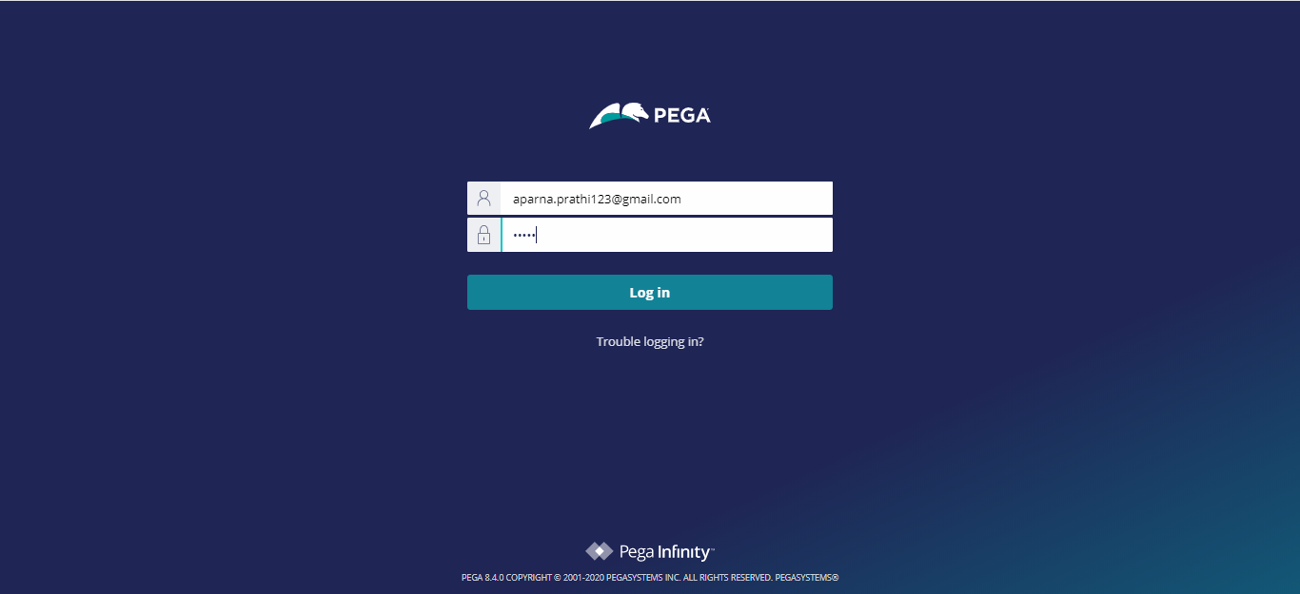

1. Patient Schedules an appointment with the doctor. In this example patient selected the visit type as General. So it will get routed to the general doctor with the skill general.(Skill Routing)

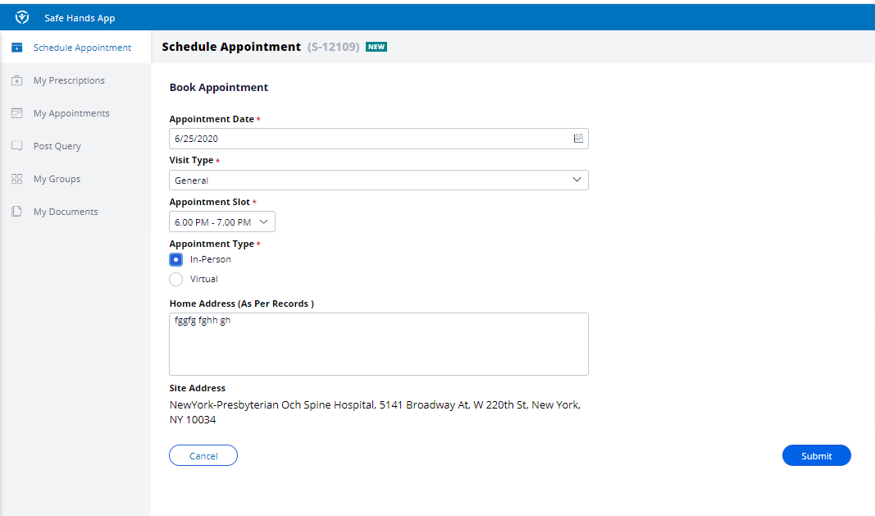

1. Submits the application and now the case is pending with the doctor

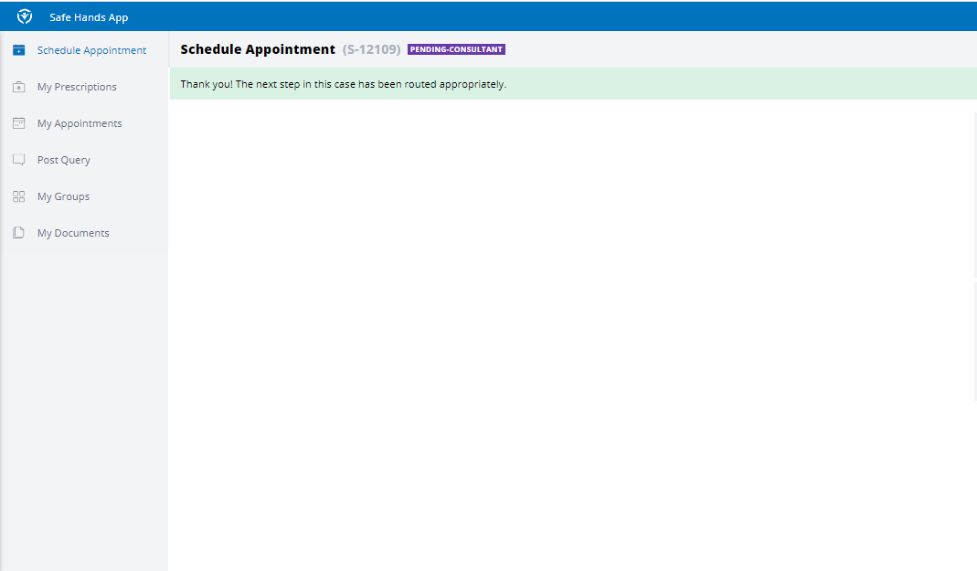

1. Patient can open his submitted applications in My Appointments.

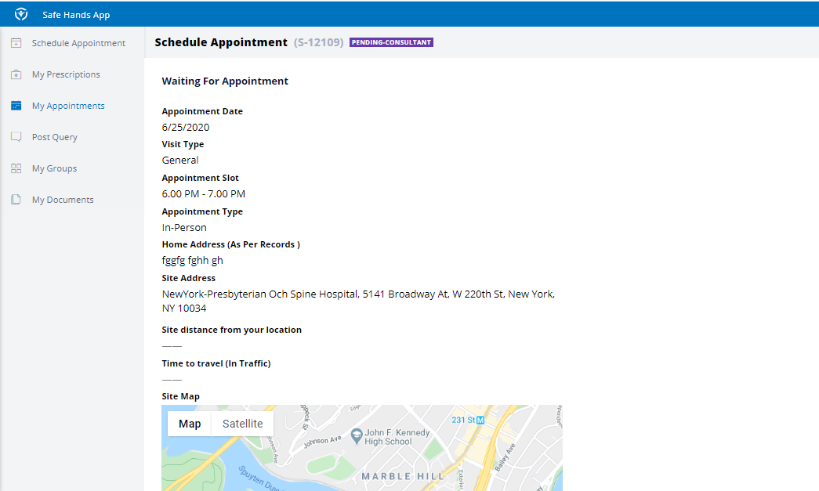

1. Doctor opens the patient case on the day of appointment and records the symptoms and gives prescriptions to the patient and submits the case.

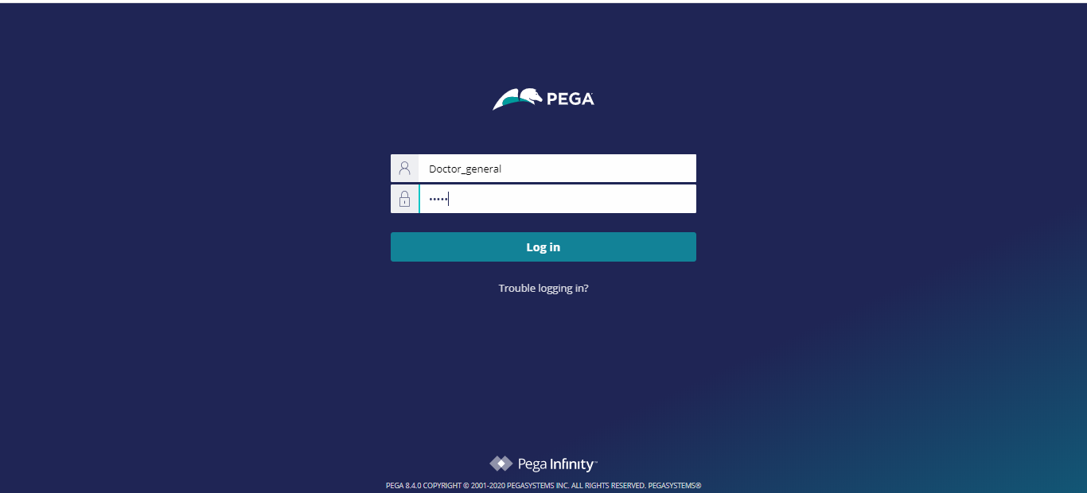

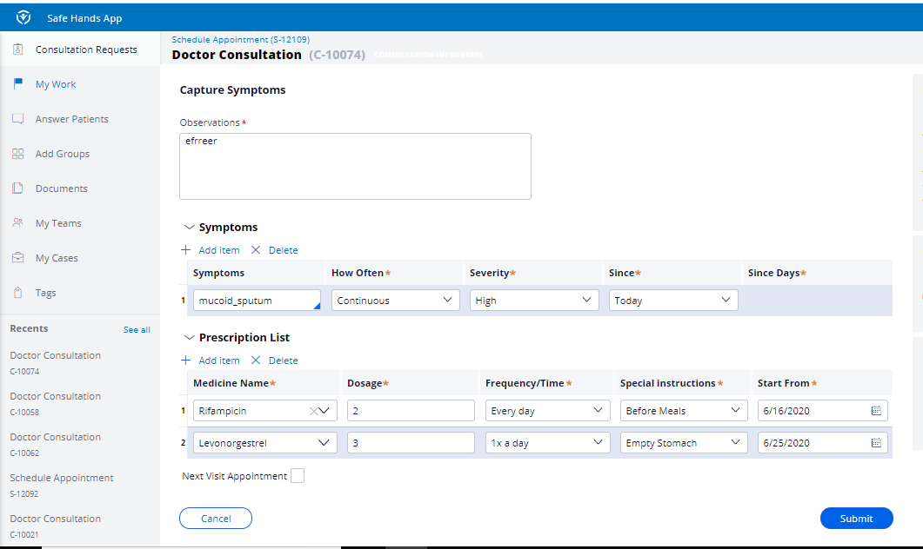

1. When doctor submits the case the case will be resolved completed.

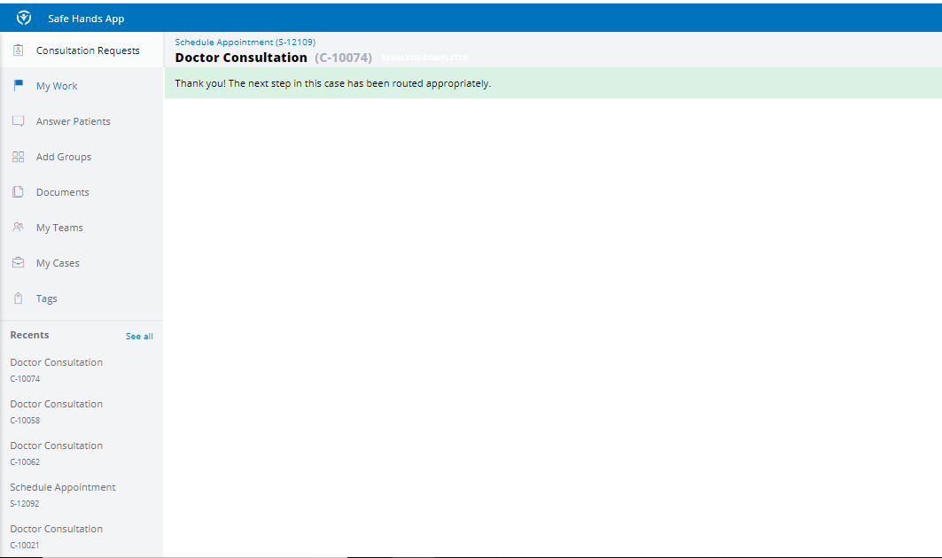

1. After consultation is completed, patient can login into the application and see his/her prescriptions in My Prescriptions.



